React State

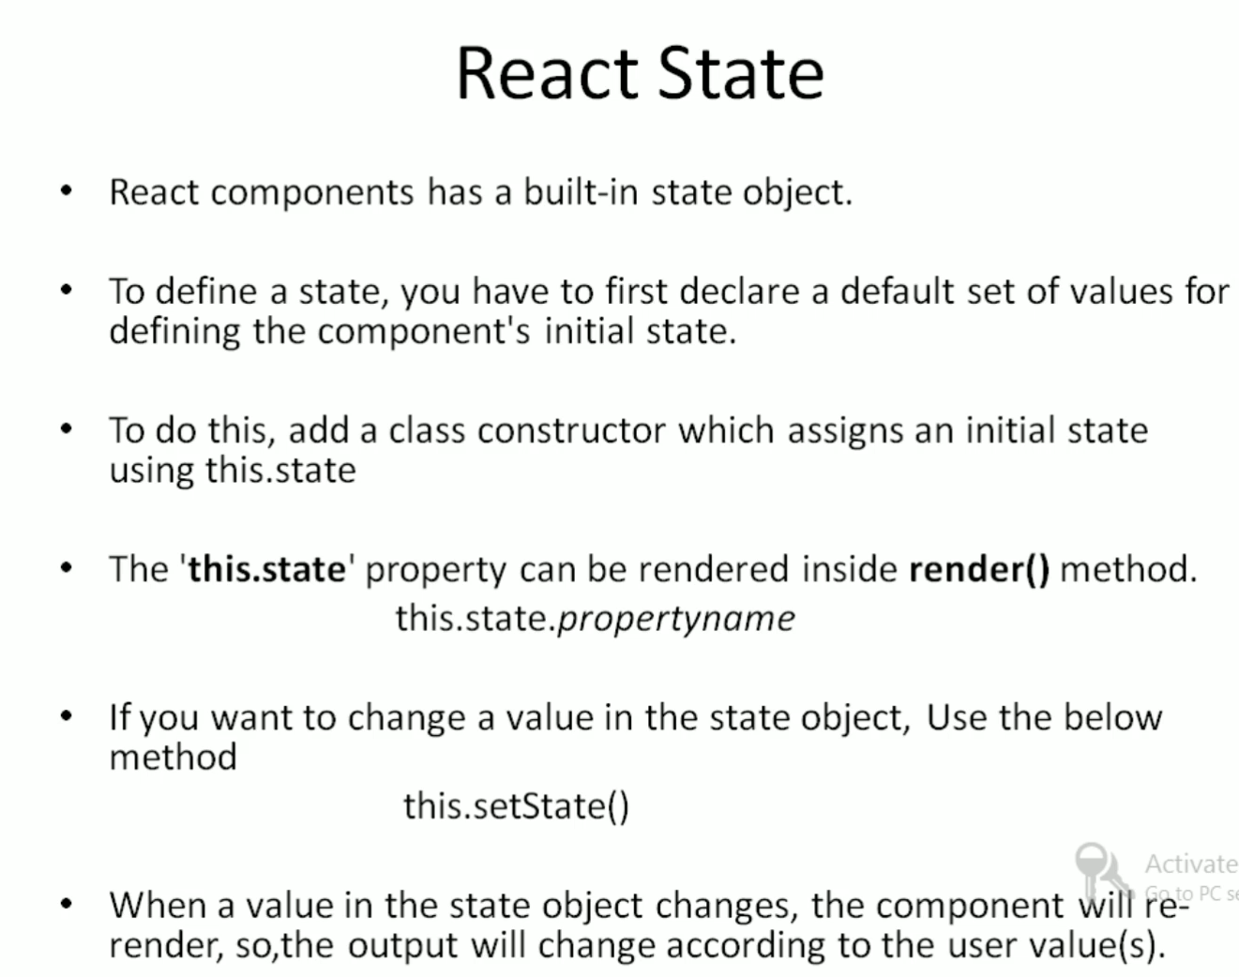

Create a folder With the name of StateDemo

Create new File 🡺 states.jsx

import React from 'react';

import ReactDOM from 'react-dom';

export default class Reactstate extends React.Component{

  constructor(){

    super();

    this.state={initialvalue:"welcome",name:"guys"}

  }

  changevalue = () =>

  {

    this.setState({initialvalue:"Thanks for watching"});

  }

  render(){

    return <div>

      <h1>{this.state.initialvalue}<span>  </span>{this.state.name}</h1>

      <br/>

      <button onClick={this.changevalue}>Exit</button>

    </div>

  }

}

App.js

import logo from './logo.svg';

import './App.css';

import { Component } from 'react';

import Reactstate from './StateDemos/State';

class App extends Component

{

  render(){

    const v={topic:"React Js",language:"Tamil",concept:'Props'};

    return (<div>

      <Reactstate />

      </div>

      )

  }

}

export default App;

While loading the Page

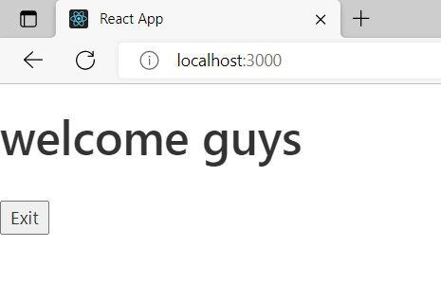

After Click the Button

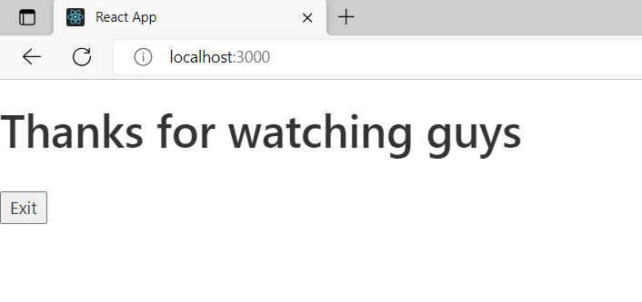

After click button should be hidden

import React from 'react';

import ReactDOM from 'react-dom';

export default class Reactstate extends React.Component{

  constructor(){

    super();

    this.state={initialvalue:"welcome",name:"guys"}

  }

  changevalue = () =>

  {

    this.setState({initialvalue:"Thanks for watching"});

    this.HideButton();

  }

  HideButton()

  {

    document.getElementById('exitbutton').hidden=true;

  }

  render(){

    return <div>

      <h1>{this.state.initialvalue}<span>  </span>{this.state.name}</h1>

      <br/>

      <button id="exitbutton" onClick={this.changevalue}>Exit</button>

    </div>

  }

}

Output

